Secure Coding Lab-3

Chekuri.mahesh

18BCN7101

L39+L40

# Find your browser installation location

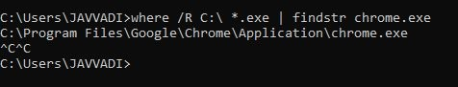

We can use this command to find the files.

# File Replication

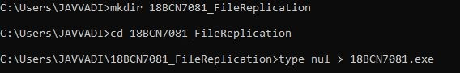

Here, I created a file which is going to be copied for 50 times in the same directory.

C:\Users\JAVVADI\18BCN7081_FileReplication>for /l %A in (1,1,50) do copy "18BCN7081.exe" "18BCN7081(%A).exe"

C:\Users\JAVVADI\18BCN7081_FileReplication>copy "18BCN7081.exe" "18BCN7081(1).exe"

1 file(s) copied.

C:\Users\JAVVADI\18BCN7081_FileReplication>copy "18BCN7081.exe" "18BCN7081(2).exe"

1 file(s) copied.

C:\Users\JAVVADI\18BCN7081_FileReplication>copy "18BCN7081.exe" "18BCN7081(3).exe"

1 file(s) copied.

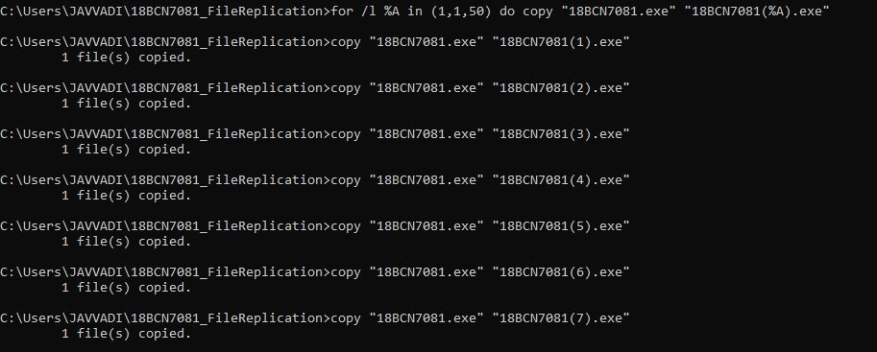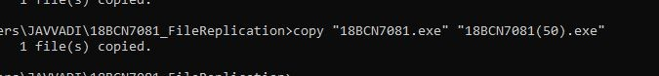

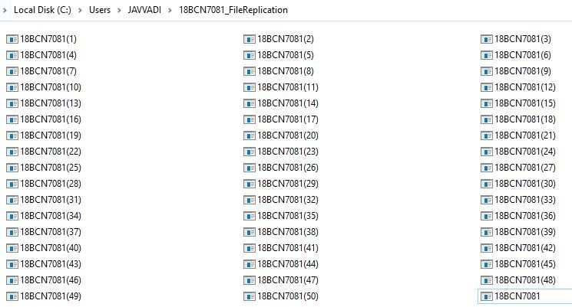

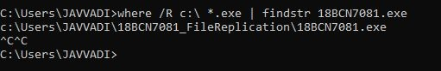

We are finding the above File using cmd.

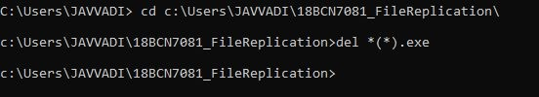

And deleting the same files that are replicated.

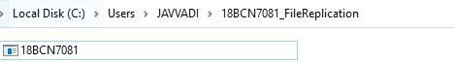

# DiskPart

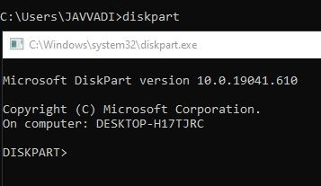

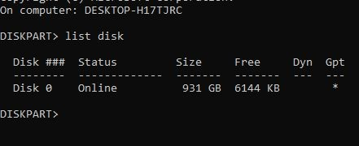

It will list out all the HDDs and SSDs present in my PC.

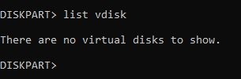

It will list out all the Virtual drives present in my PC.

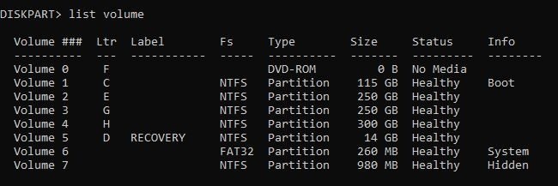

It will list out all the partitions and volumes present in my Disk 0.

# Schedule tasks : schtasks

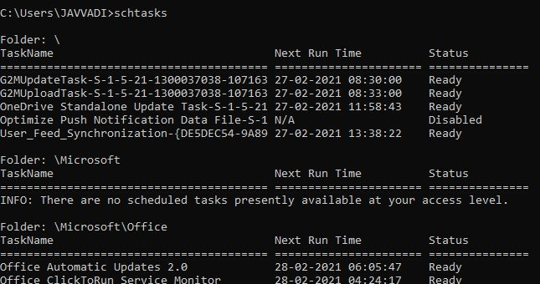

•Running Schtasks.exe without arguments displays the status and next run time for each registered task.

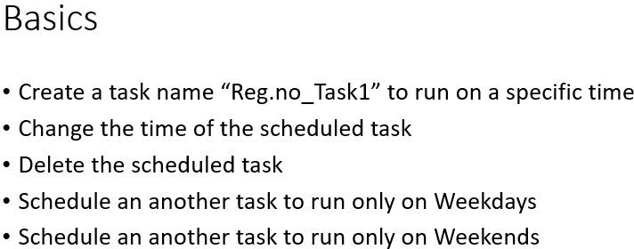

## 1)

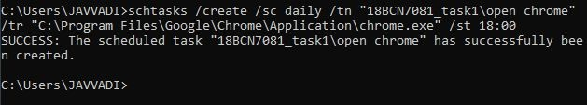

We have created a task named “18BCN7081_task1” scheduled daily at 18:00.

## 2)

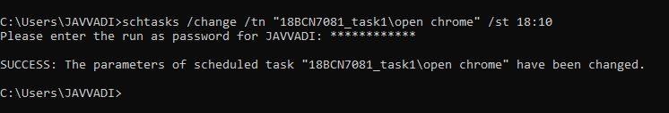

We have changed the time of scheduled task to 18:10

## 3)

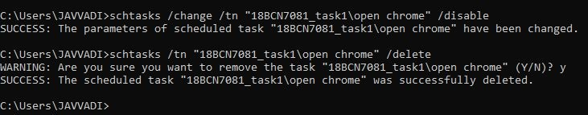

We have disabled and deleted the scheduled task.

## 4)

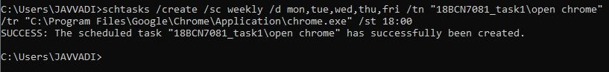

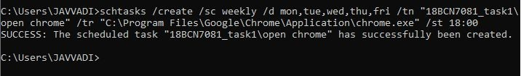

We have created a new task which runs only on weekdays.

## 5)

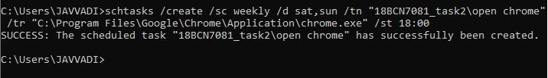

We have created a new task which runs only on weekends.